**Homework 5**

**Code**

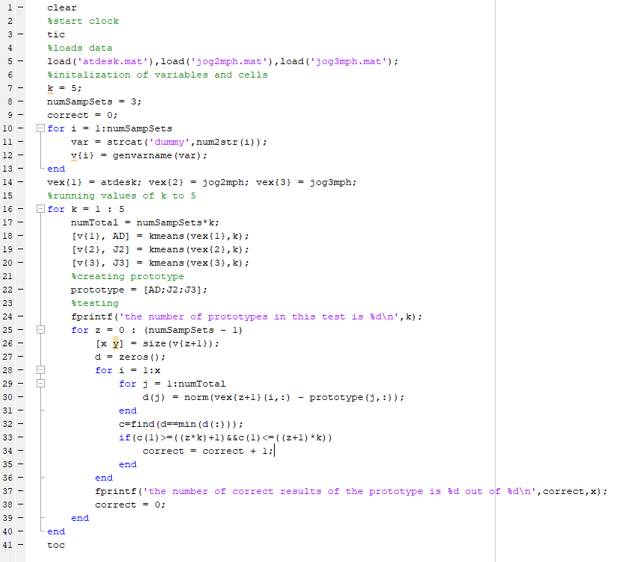

Figure 1 Main code

The code above will run and automatically test all the values from k = 1 to k = 5. This will print out the results below.

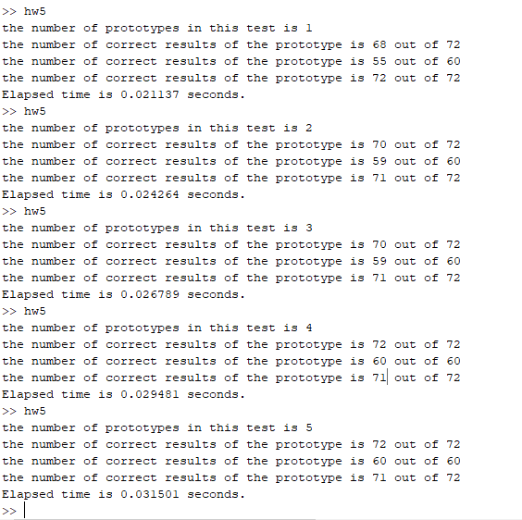

Figure 2 example results

Looking at the results above this looks to show that prototyping with more and more doesn’t really mean you get exponentially greater results. If you look to 3, 4, and 5. That shows that one doesn’t need to really have 4 or 5 prototypes for this case. And if you look at 1 you can see that it is kind of lacking and 2 comes in at one more and makes it near perfect. So one doesn’t really need a whole lot of prototypes to be effective. W/ these result you can go with 2 or 3 without a worry or a 4 if you need to be stricter.